01/03/2019-

TALKING POINTS
RADIO INTERVIEW WITH RICK ALLEN COPPER COUNTRY TODAY:

Media Contact:
Stephanie Krieger
Chair of Strategic Initiatives-
UPHT Task Force
P: (989) 245-3760
E: steph@s7consulting.com
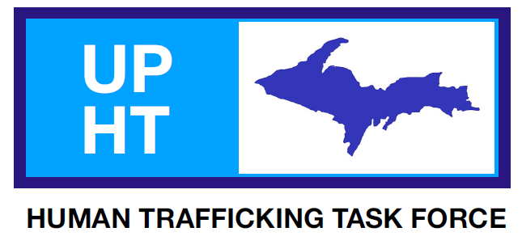

Call out to all UP citizens:
Q: IS HUMAN TRAFFICKING REALLY HAPPENING HERE IN THE UP?
A: YES-

Why?
Isolation
Large land mass
Waterways
Ports
Native Indian Communities
Poverty
Drug and Alcohol addictions

WHERE THERE IS DRUGS, THERE IS TRAFFICKING

Join the fight against Human trafficking crimes right here in the UPPER PENNISULA.

Talking Point #1: UPPER PENINSULA HUMAN TRAFFICKING TASK FORCE
MISSION STATEMENT: Building and maintaining a collaborative effort in combatting the Human Trafficking problem in the UP of Michigan with a multi-disciplinary approach.

- The Upper Peninsula Human Trafficking Task Force (UPHTTF) includes members from the Department of Justice (DOJ), U.S. Homeland Security Investigation's (HSI), several UP Law Enforcement agencies, Tribal communities (KBIC, Sault Tribe) and social service providers in taking a stand against the violent crime of Trafficking in PERSONS. Join the Fight- Like our Page-Stand with us today!

Talking Point #2:

- 2017 MICHGAN STATE REPORT ON HUMAN TRAFFICKING –

  - Polaris Projects National Human Trafficking Hotline Statistics

MI Attorney General main initiative to fight human trafficking in our state.

Incoming new AG Dana Nessel is carrying the torch in continuing to make anti-human trafficking initiatives in our state one of her main priorities-

Upon taking office in 2011, Schuette launched the state’s first Human Trafficking Unit in the Attorney General’s Office to prosecute human traffickers under state law. Since then, Schuette's Human Trafficking Unit has arrested 24 individuals on human trafficking charges and secured 18 human trafficking convictions, with cases against several additional defendants currently pending.
Example Case #1: Amber Speed, 40 of Lansing, charged with multiple 20-year felonies, including Minor Sex Trafficking, Pandering, Accepting the Earning of a Prostitute and Debt Bondage.

Example Case # 2: Tremaine Woodall, 19 of Warren, charged with two counts of Human Trafficking – Recruiting a Minor for Commercial Sexual Activity, and two counts of Pandering for sex trafficking a 17-year-old and attempting to sex traffic a 16 year old.

Talking Point #3

JANUARY IS NATIONAL HUMAN TRAFFICKING AWARENESS MONTH

In honor of January National Human Trafficking Awareness Month -the UPHTTF will be hosting several community awareness events throughout the UP through Communities that Care locations. More dates and locations to come.

To learn more on how you can join the fight go to our Facebook Page and LIKE

https://www.facebook.com/UPHTTF

We need you!

We are currently seeking committee members to assist throughout our UP.
What talents can you contribute?

Committees: Education, Law Enforcement, Victim Services, Hospitality/CVB, Healthcare, Fundraising, Strategic Initiatives, Media, Community Awareness, Training, Faith

For more information on getting more involved on the UP Human Trafficking Task Force, reach out to the UPHTTF Group Leader/ Administrator
Marlene Mottes located in Marquette MI at 906-226-1422.

