
Timothy Ellison
Public Affairs Officer
Oscar G. Johnson
VA Medical Center
325 East H Street
Iron Mountain, MI 49801
(906) 774-3300, (800) 215-8262
Ext 32018
www.ironmountain.va.gov
News Release

FOR IMMEDIATE RELEASE
December 18, 2023

Secretary McDonough visits Veterans Affairs clinic in Hancock, MI.

HANCOCK, Mich - The Secretary of the Department of Veterans Affairs Denis McDonough, visited the Iron Mountain VA Medical Center and the Hancock VA Community Based Outpatient Clinic (CBOC) Friday to speak with leadership, tour the facilities, and meet with employees.
“The visit provided many opportunities for the Secretary to interact with staff and express his appreciation for a job well done. Our meetings yielded positive feedback regarding potential future rural health initiatives,” said John P. Shealey, Medical Center Director. Shealey went on to say, “We are truly honored that the Secretary and Representative Bergman have expressed an interest in rural health care and the role our facility plays in meeting the needs of our Veterans.”
Dr. Audrey Liston, and Dr. Allison Helman, Hancock CBOC Primary Care Providers, were individually recognized by the Secretary for their outstanding commitment to the ICARE values and the mission of the VA, to fulfill President Lincoln's promise to care for those who have served in our nation’s military and for their families, caregivers, and survivors. They both received a challenge coin from McDonough and the personal thanks of the Secretary and Representative Bergman.
"The Hancock clinic strives to give great care and to have this recognized by the Secretary was an honor.” Liston shared.
McDonough, Bergman, and others visited with Veterans coming and going from their appointments and toured the clinic. The Secretary also took a few minutes to discuss the great work Dr. Christy Girard, Chief of Mental Health, and her staff have been doing.
"It was great to be able to show the Secretary all the hard work that our department accomplishes for Veterans and discuss the challenges of recruitment in a highly rural area,” Girard explained. “It was so positive to see how much he is invested in improving VA."

# # #

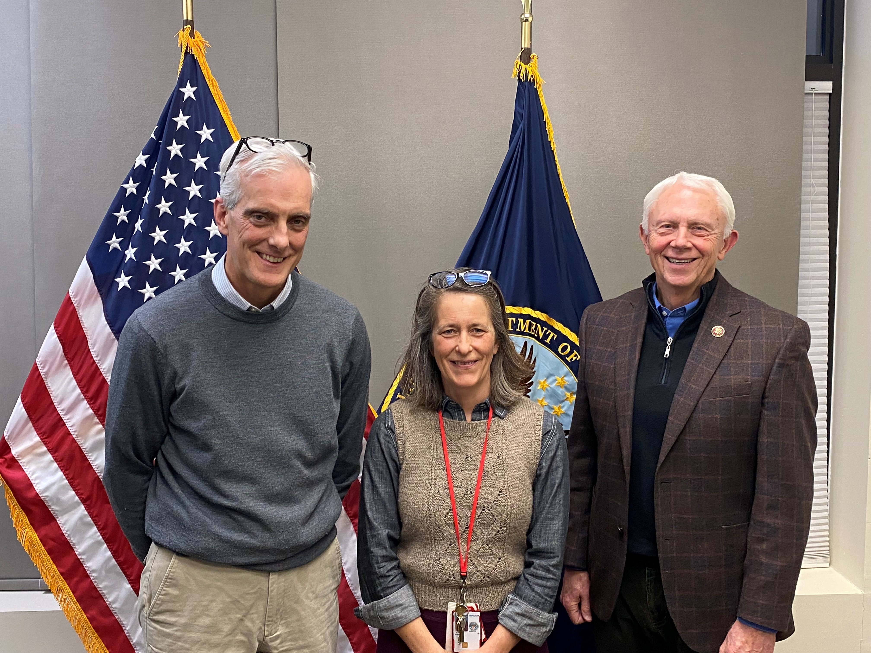
(SECVA_Visit_Houghton_001)
Oscar G. Johnson VAMC Associate Chief of Primary Care Audrey Liston (center) is pictured with Department of Veterans Affairs Secretary Denis McDonough (left) and Representative Jack Bergman (right), during a visit to the Hancock Community-based Outpatient Clinic December 15, 2023.

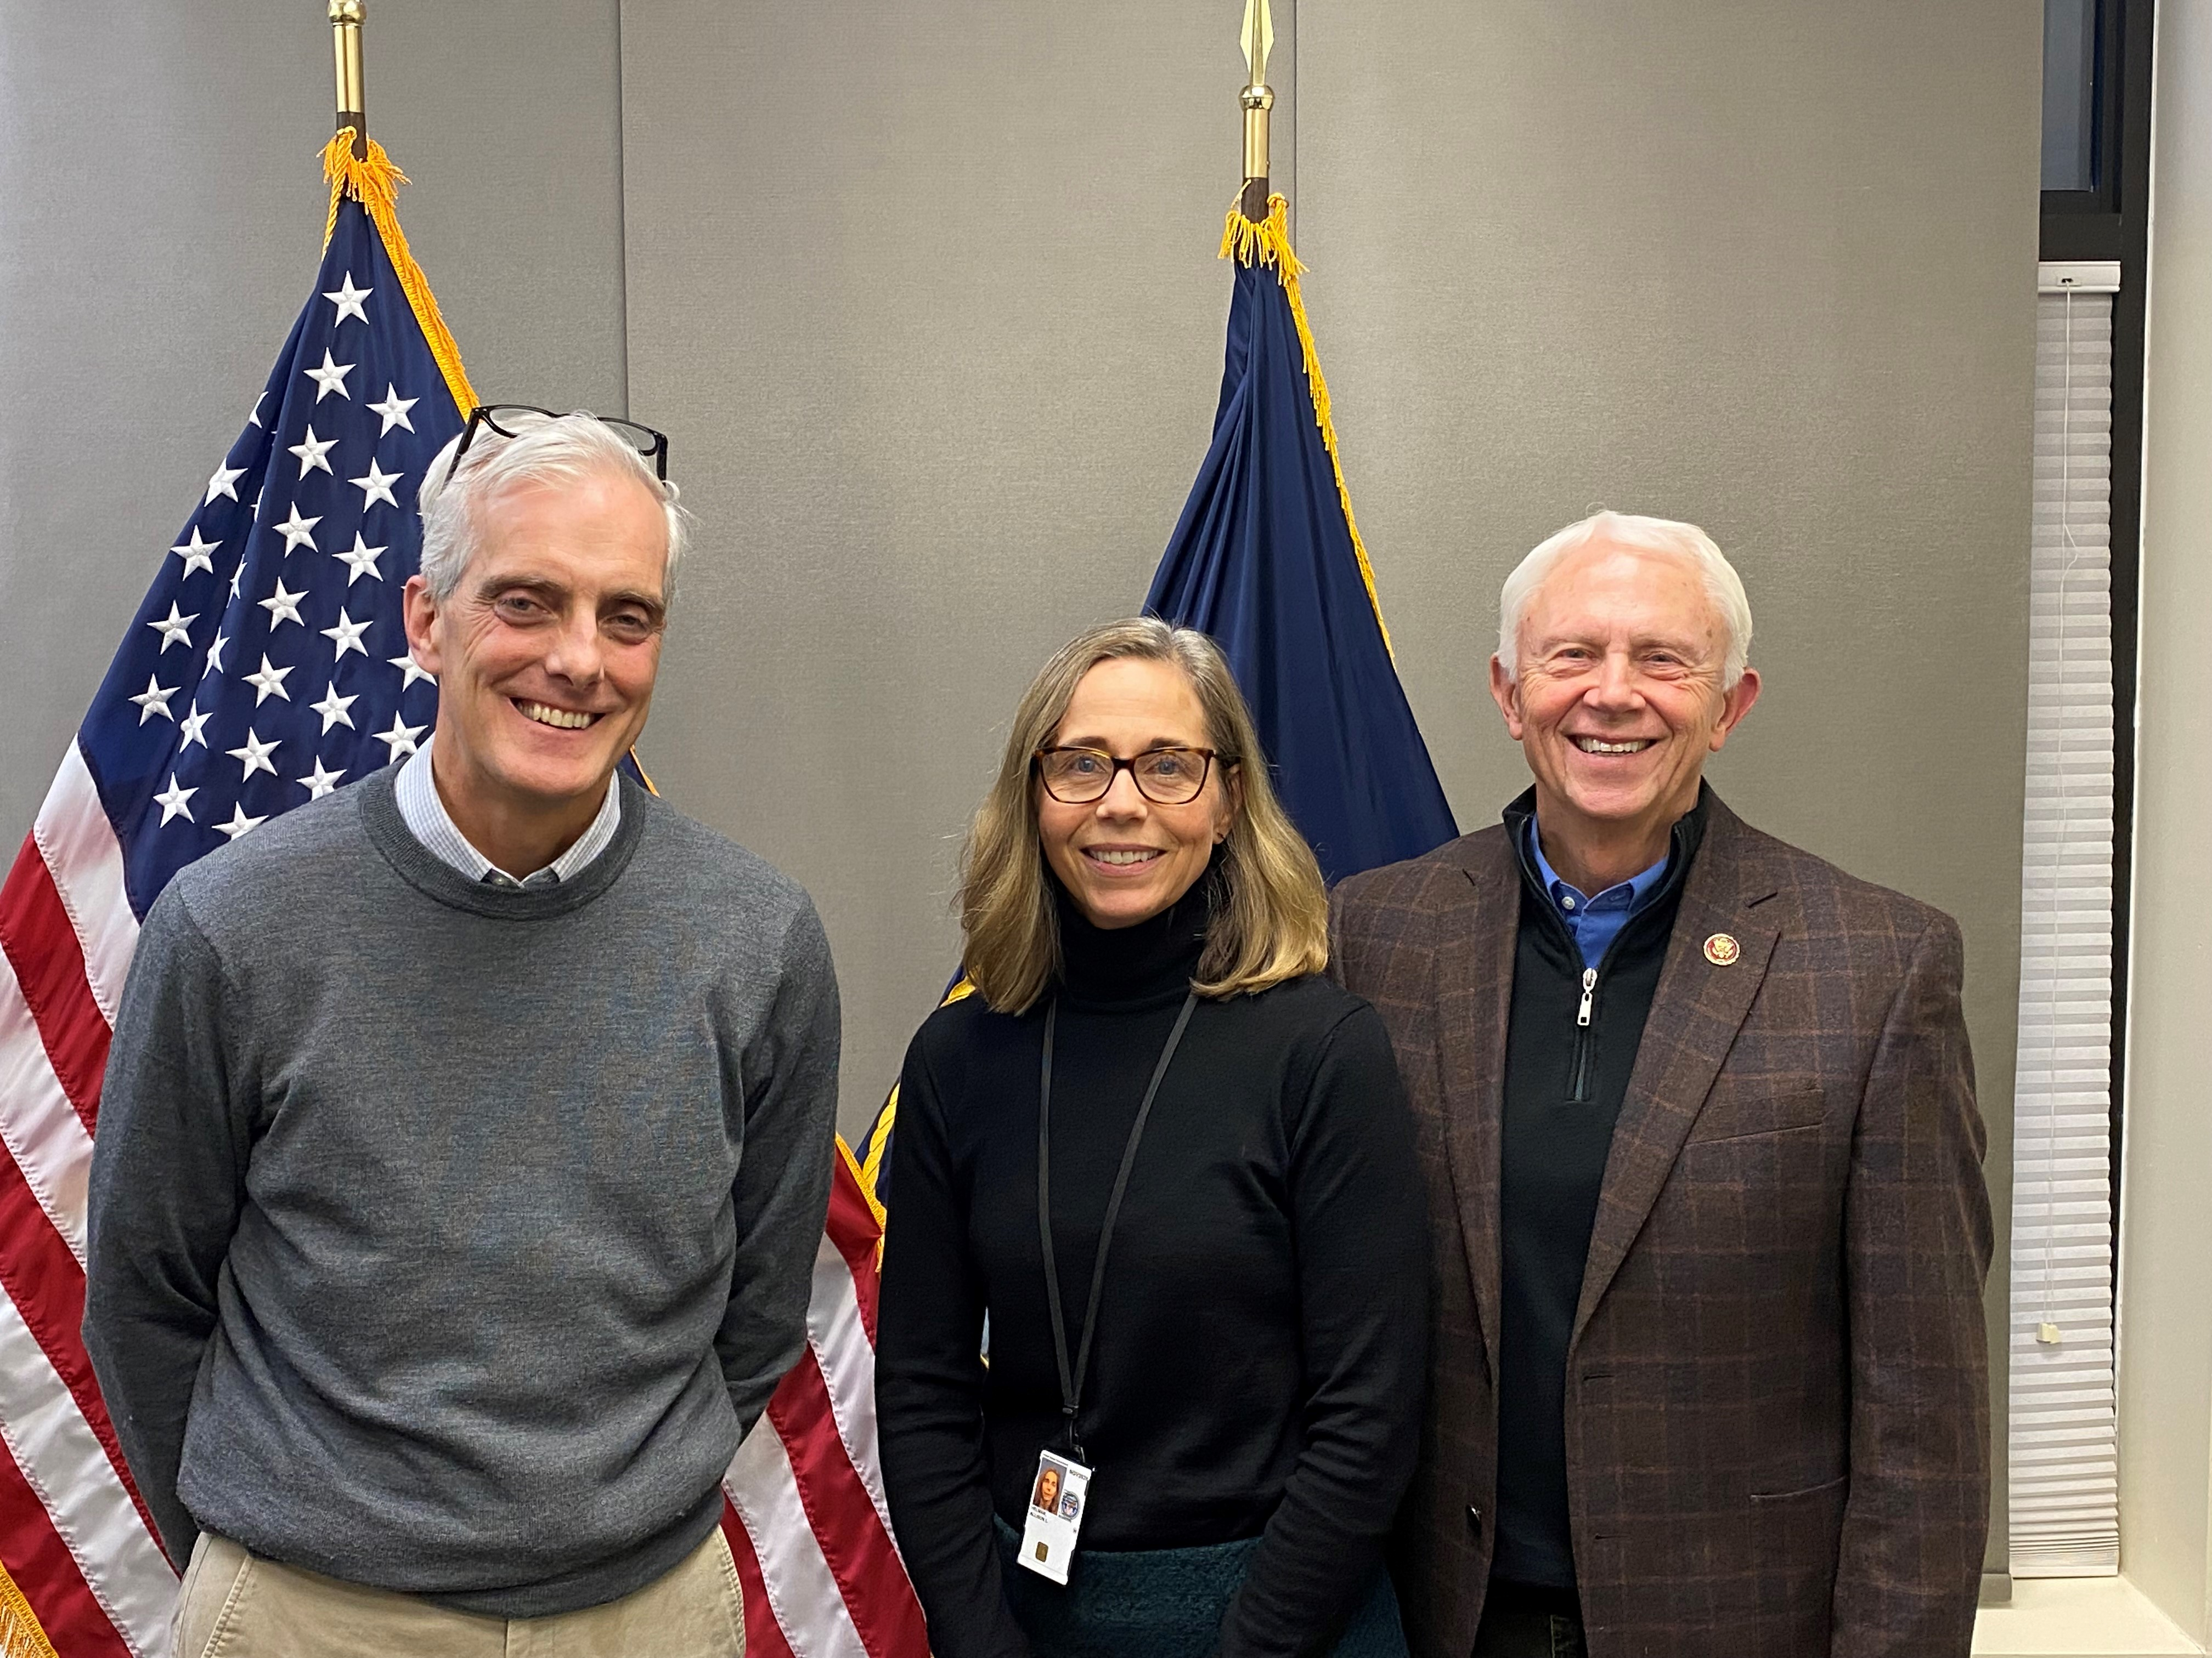
(SECVA_Visit_Houghton_002)
Oscar G. Johnson VAMC Associate Chief of Primary Care Allison Helman (center) is pictured with the Department of Veterans Affairs Secretary Denis McDonough (left) and Representative Jack Bergman (right), during a visit to the Hancock Community-based Outpatient Clinic December 15, 2023.

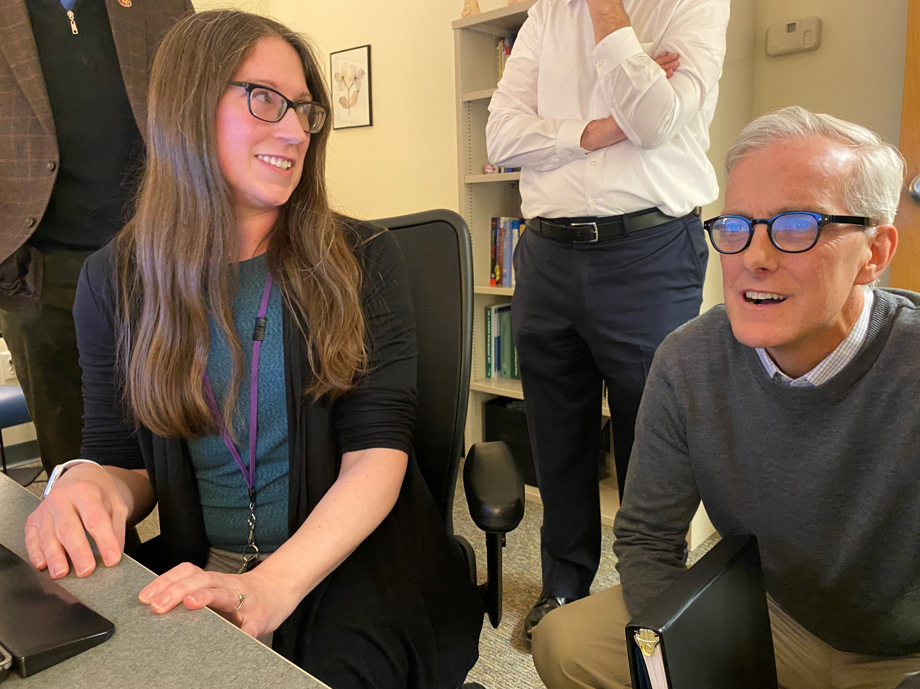
(SECVA_Visit_Houghton_003)
Oscar G. Johnson VAMC Chief of Behavioral Health Christy Girard (left) is pictured with Department of Veterans Affairs Secretary Denis McDonough (right) going over quality data during a visit to the Hancock Community-based Outpatient Clinic December 15, 2023.

####

